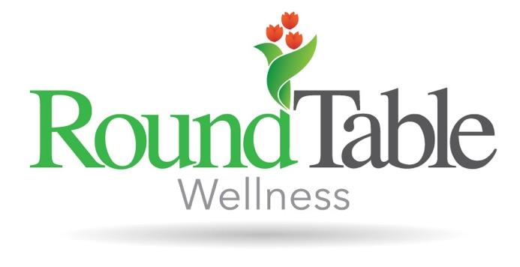
Ellen received her bachelor’s degree from Purdue University and her master’s degree from Indiana State University. She is a Registered Dietitian Nutritionist accredited by the Commission on Dietetic Registration and a Certified Intuitive Eating Counselor. Ellen believes in using an evidence-based approach while also utilizing Intuitive Eating and the Health at Every Size® perspective when working with clients. Ellen realizes that eating patterns and habits are individualized. She understands that the key to true health and wellness can be achieved by rejecting the diet culture and messaging that surrounds us every day and focusing on what works best for our own personal health. Ellen is deeply passionate about helping others ditch the diet rules and rediscover the joy of eating. It is through compassion and empathy, that Ellen strives to help others redefine health and discover their own path to food peace.

