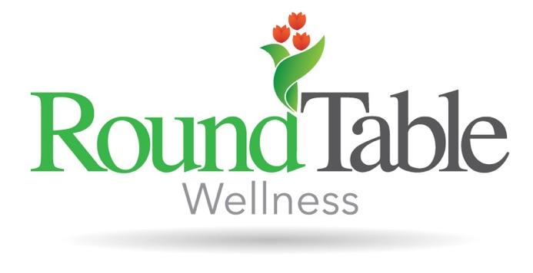
Abby received her bachelor’s degree in Psychology from Indiana State University and her master’s degree in Mental Health Counseling and Art Therapy from the University of Indianapolis. Abby is a Licensed Mental Health Counseling Associate (LMHC-A) and a Registered Art Therapist- Provisional (ATR-P). Prior to her work at RoundTable Wellness, Abby worked with a variety of populations in various settings within the mental health field ranging from group therapy centers to neuroscience facilities. Abby enjoys facilitating individual and group therapy and uses approaches such as Art Therapy, Cognitive Behavioral Therapy (CBT), Mindfulness, Internal Family Systems (IFS), and Motivational Interviewing. Abby is currently the program therapist for the intensive outpatient program. Abby enjoys utilizing art therapy as a foundation with clients in order to offer a method of communication that does not rely solely on verbal communication, as well as a way to build confidence and trust with self.

