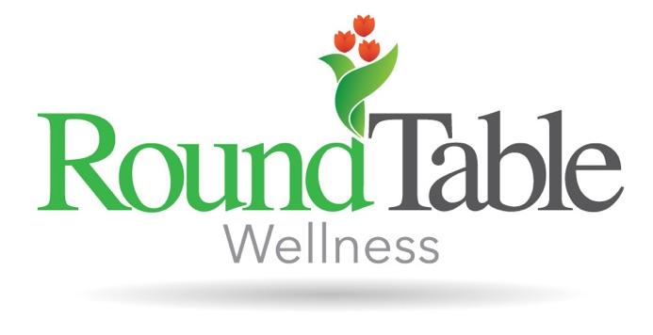
My name is Ariana (she/her/hers), and I provide therapy to adolescents and adults struggling with life's uncertainty. I received my Master of Arts in Clinical Mental Health Counseling from Ball State University and hold my Mental Health Counselor Associate license (LMHC-A) in the state of Indiana. I serve as the secretary for the Indiana Counselors Association and am passionate about holistic health. One of my favorite quotes is, "where you've struggled the most is where you have the most to give -- if you do your work." My intention for our therapy sessions is for those to be your work. Together, we will examine how to shift your habits and re-vitalize your self-talk. We will find purpose in your struggles and set goals to push you forward. My therapeutic style is collabortive and person-centered. I utilize tools from Cognitive Behavior Therapy (CBT) and Dialectical Behavior Therapy (DBT) and pull heavily from mindfulness. I have experience providing therapy to children, adolescents, and adults. I utilize a variety of modalities in-session including videos, worksheets, role-playing, humor, psychoeducation, and deep breathing. My hobbies include joyful movement, discovering new coffee shops, interior decorating, listening to music, and spending time with friends and family.

